Session Management or State Management
HTTP stands for Hyper Text Transfer Protocol
HTTP is stateless protocol, every request send by client to server is a new request. Server does not remembers the request is comes from which client. To remember client by server, we use session management or state management.

In the context of the web, a session is a temporary way for a server to remember a user's information and activities over a period of time. Since the standard web protocol (HTTP) is "stateless"—meaning each request is treated as brand new with no memory of previous ones—sessions provide the "short-term memory" necessary for modern websites to function.

Types of session management
- Using hidden form fields (client side)
- URL re-writting
- Using cookies (client side)
- Using session framework provided django (server side)

Hidden form fields
Hidden form fields are a technique for session management where non-visible HTML input tags are used to store and pass state information between the client and server.

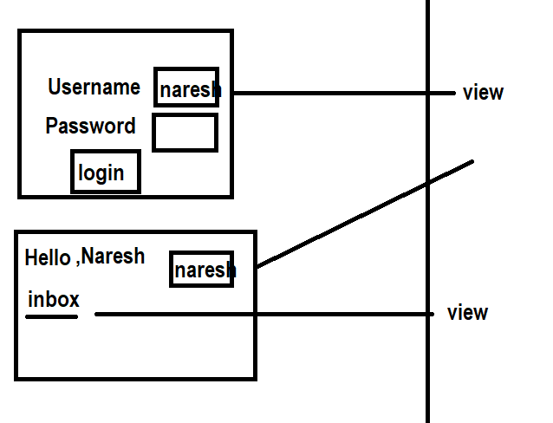
Views.py
from django.shortcuts import render
from django.http import HttpResponse
# Create your views here.
users={'naresh':'nt123',
'suresh':'s324',
'ramesh':'k567',
'kishore':'k789'}
def login_view(request):
if request.method=="GET":
response=render(request,"login.html")
return response
elif request.method=="POST":
user=request.POST.get("user")
pwd=request.POST.get("pwd")
if user in users and users[user]==pwd:
response=render(request,"inbox.html",context={'user':user})
return response
else:
response=render(request,"login.html",context={'msg':'invalid username or password'})
return response
def inbox_view(request):
user=request.GET.get("user")
response=HttpResponse(f"<h2>This is inbox of {user}</h2>")
return response

login.html
<!DOCTYPE html>
<html lang="en">
<head>
<meta charset="UTF-8">
<meta name="viewport" content="width=device-width, initial-scale=1.0">
<title>Document</title>
</head>
<body>
<form method="post">
{%csrf_token%}
<table border="2" width="100%">
<tr>
<td>UserName</td>
<td><input type="text" name="user"></td>
</tr>
<tr>
<td>Password</td>
<td><input type="password" name="pwd"></td>
</tr>
<tr>
<td><input type="submit" value="login"></td>
<td><input type="reset" value="clear"></td>
</tr>
</table>
</form>
{{msg}}
</body>
</html>

Inbox.html
<!DOCTYPE html>
<html lang="en">
<head>
<meta charset="UTF-8">
<meta name="viewport" content="width=device-width, initial-scale=1.0">
<title>Document</title>
</head>
<body>
<h2>Hello,{{user}}</h2>
<form action="/inbox">
<input type="hidden" value="{{user}}" name="user">
<input type="submit" value="inbox">
</form>
</body>
</html>

Urls.py
from django.contrib import admin
from django.urls import path
from app.views import login_view
from app.views import inbox_view
urlpatterns = [
path('admin/', admin.site.urls),
path('login/',login_view),
path('inbox/',inbox_view),

]

Settings.py
INSTALLED_APPS = [
'django.contrib.admin',
'django.contrib.auth',
'django.contrib.contenttypes',
'django.contrib.sessions',
'django.contrib.messages',
'django.contrib.staticfiles',
'app'
]

TEMPLATES = [
{
'BACKEND': 'django.template.backends.django.DjangoTemplates',
'DIRS': [BASE_DIR/"templates"],
'APP_DIRS': True,
'OPTIONS': {

Cookies
In Django, cookies are small pieces of text sent by the server to a user's browser to store persistent data between requests. They are primarily managed through the HttpResponse and HttpRequest objects.

Types of cookies
- Persistent cookies
- Non persistent cookies

Non persistent cookies are exists until browser is opened, when browser closed it deletes all cookies
Persistent cookies are exists for specific time period (age). This cookies are exists after closing browser.

Problem with cookies
- Cookies cannot hold large of amount data
- Cookies can hold text type of data
- Cookies are not secured because these are stored inside client browser
- Client is having option to enable or disable cookies. If cookies are disable the web site does not work properly

To work with cookies HttpRequest and HttpResponse provided some methods.

HttpResponse provides the following for creating or updating cookie

Syntax: response.set_cookie(key, value, max_age=None, expires=None, path='/', domain=None, secure=False, httponly=False, samesite=None).

HttpRequest provides the following methods for reading cookies from browser/request object

request.COOKIES.get('cookie_name', 'default_value')
request.COOKIES[‘cookie-name’] 🡪 KeyError
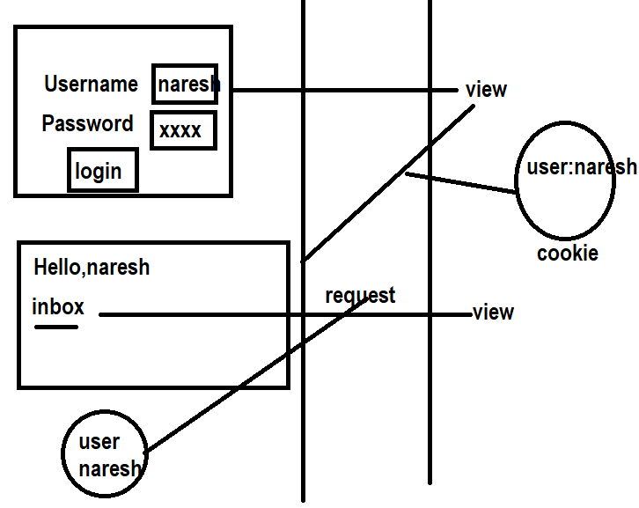

Views.py
from django.shortcuts import render
from django.http import HttpResponse
# Create your views here.
users={'naresh':'nt123',
'suresh':'s324',
'ramesh':'k567',
'kishore':'k789'}
def login_view(request):
if request.method=="GET":
response=render(request,"login.html")
return response
elif request.method=="POST":
user=request.POST.get("user")
pwd=request.POST.get("pwd")
if user in users and users[user]==pwd:
response=render(request,"inbox.html",context={'user':user})
response.set_cookie('user',user)
return response
else:
response=render(request,"login.html",context={'msg':'invalid username or password'})
return response
def inbox_view(request):
user=request.COOKIES.get('user')
response=HttpResponse(f"<h2>Inbox of {user} </h2>")
return response

